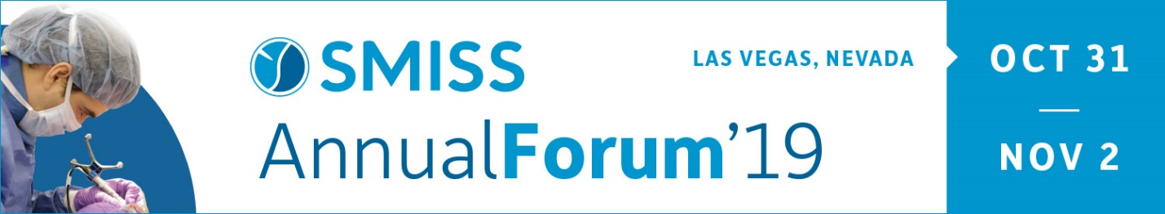

[BUSINESS NAME] exhibiting at SMISS Annual Forum ’19.
This fall, [Insert business name] will travel to Las Vegas, NV for SMISS Annual Forum ’19, taking place October 31-November 2 at Aria Resort & Casino. Widely considered to be the #1 meeting in minimally invasive spine surgery, SMISS Annual Forum gathers hundreds of spine surgeons and other industry professionals who include MISS in their practices.
Attendees benefit from a CME-accredited scientific program including abstracts, invited lectures, debates, case discussions, and new this year, “Meet the Expert” Q & A. The meeting also features exhibits, non-CME workshops, tech updates, and a pre-course cadaveric lab. Annual Forum ’19 also offers a young surgeon grant program and educational track.
The course chairmen, Christoph Hofstetter, MD; Stephen Ryu, MD; Kern Singh, MD; and William Taylor, MD, have gathered experts from around the world to participate as faculty, in addition to the SMISS Board of Directors. The Friday evening reception is a fun way for faculty, participating surgeons, and exhibitors to connect.
Come visit [insert business name] at Booth Number [#] at SMISS Annual Forum ’19. In addition, you can spot [insert business name] at [insert workshop, cadaveric lab, tech update, other support]. [Insert quote from your company, why you participate, or other background].
More information, including the preliminary program, faculty list, and registration details, can be found at smissmeeting.org.
About [Insert business name]: [Include a brief history of your company, including contact information].

*USE AS PRESS RELEASE*

